Full Stack Development – Project Documentation
Import Data using Transform Maps (Spreadsheet)
Built on the ServiceNow platform (Import Sets, Transform Maps, Reports and Dashboards)
Note on the stack: the standard documentation format is written for a MERN project (React, Node.js, Express.js, MongoDB). This project is built on the ServiceNow low-code platform instead, so each section below documents the ServiceNow equivalent and says clearly where a MERN item does not apply (for example there is no npm, no custom REST API and no JWT).

1. Introduction
Project title: Import Data using Transform Maps (Spreadsheet)
Team ID: SWTID-2026-5228
Team members:
Name | Role | Responsibility
Divya Shree S | Team Leader | Data transformation and validation
Harini V | Team Member | Spreadsheet, tables and Import Set table setup
Harshini S | Team Member | Transform Map, reports and dashboard
Harshini K | Team Member | Duplicate prevention (Coalesce)
Harshini P | Team Member | Data insertion (new data in Excel format)

2. Project Overview
Purpose: To import bulk employee data from an Excel spreadsheet into ServiceNow accurately and without duplicate records. The spreadsheet is loaded into an Import Set (staging) table, moved into the Employee Test table by a Transform Map, and then shown in reports on a dashboard.
Features:
- Custom Employee Test table (u_employee_test) with Employee ID, Employee Name, Email, Department and Location.
- Excel upload with System Import Sets > Load Data into the Employee Import staging table (u_employee_import).
- Transform Map “Sample Spreadsheet Import” with Auto Map Matching Fields and Mapping Assist.
- Coalesce on Employee ID, so re-importing existing employees updates them instead of inserting duplicates.
- Transform History with the inserted, updated, ignored and error counts of every import.
- Reports: Employees by Department (pie chart), Employees by Location (bar chart) and Employee List Report, shown on the Employee Analytics Dashboards dashboard.

3. Architecture
The application runs entirely on a ServiceNow Personal Developer Instance (PDI) and is accessed through a browser. The figure shows how the layers fit together.
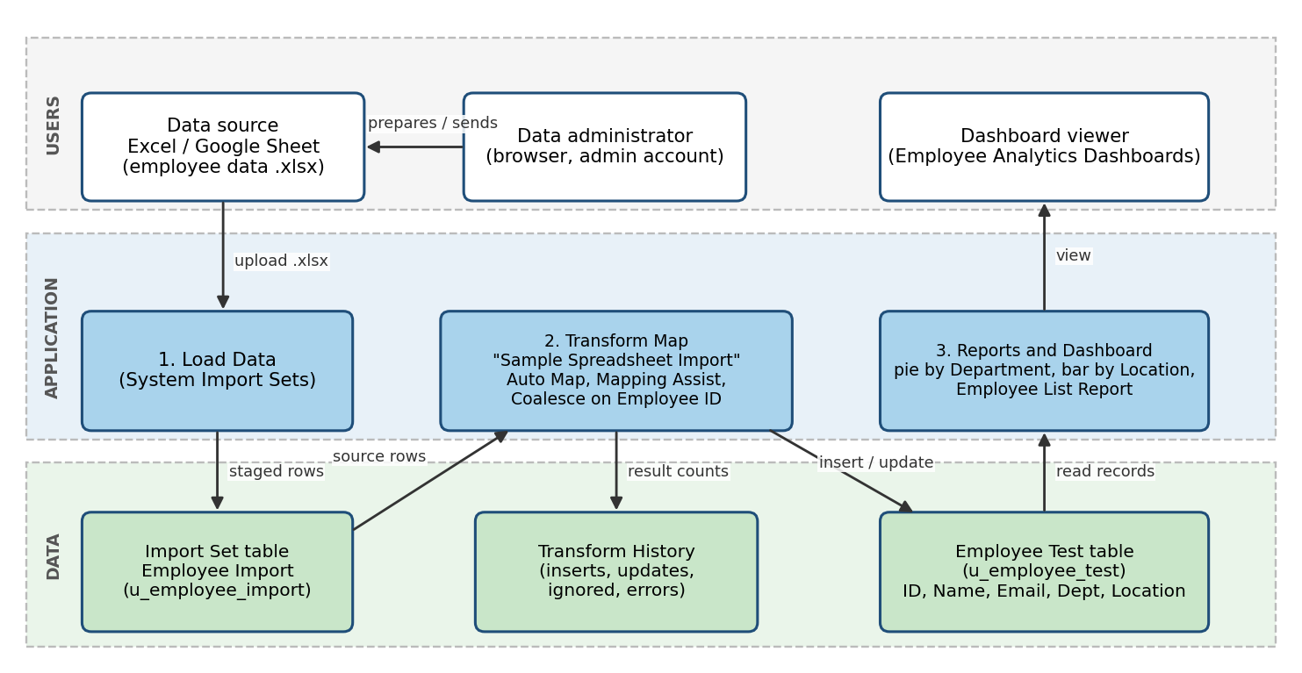
Figure 1: Architecture and data flow of the solution
Frontend (instead of React): the ServiceNow web UI in the browser. The Load Data page, the Table Transform Map form, list and form views, the Reports editor and the Dashboard are all standard ServiceNow UI, so no custom frontend code was written.
Backend (instead of Node.js / Express.js): the ServiceNow platform server. The Import Set engine loads the file into the staging table and the Transform engine runs the Transform Map and writes to the target table. No custom server code or routes were written.
Database (instead of MongoDB): ServiceNow tables on the instance database. The schema and interactions are described below.
Database schema
Table | Field (column name) | Notes
Employee Test (u_employee_test)  target table | Employee ID (u_employee_id)  Employee Name (u_employee_name)  Email (u_email)  Department (u_department)  Location (u_location) | All fields are of type String. Employee ID is the coalesce field.
Employee Import (u_employee_import)  Import Set / staging table | u_employee_id, u_name, u_email,  u_department, u_location | Created by Load Data from the header row of the sheet (Employee ID, Name, Email, Department, Location).
Transform History | Total, Inserts, Updates, Ignored, Skipped, Errors | Written by the platform for every transform run.
Field mapping (Transform Map: Sample Spreadsheet Import)
Source field (Employee Import) | Target field (Employee Test) | Coalesce
u_employee_id | u_employee_id | true
u_name | u_employee_name | false
u_email | u_email | false
u_department | u_department | false
u_location | u_location | false
Interactions: Load Data inserts the sheet rows into the staging table; the transform reads each staged row, looks for an Employee Test record with the same Employee ID (Coalesce), then updates it if it exists or inserts a new record if it does not; the reports read the Employee Test table.

4. Setup Instructions
Prerequisites
- A ServiceNow Personal Developer Instance (PDI) and an account with the administrator role.
- A web browser.
- Google Sheets or Microsoft Excel to prepare the data file.
- Node.js, MongoDB and npm are not required for this project.
Installation and setup (there is nothing to clone or install; the artefacts are created on the instance)
- Prepare the sheet: create a spreadsheet with the header row Employee ID, Name, Email, Department, Location and some employee rows, then download it as Sample Spreadsheet.xlsx.
- Create the table: open Tables > Create New, enter Label “Employee Test” (name u_employee_test) and save. Open Form Layout and add the String fields Employee ID, Employee Name, Email, Department and Location.
- Load the data: open System Import Sets > Load Data, choose Create table, Label “Employee Import” (name u_employee_import), choose the file, Sheet number 1, Header row 1, and click Submit.
- Create the Transform Map: on the success page click Create Transform Map, name it “Sample Spreadsheet Import”, set the target table to Employee Test, click Auto Map Matching Fields, then use Mapping Assist to map the remaining fields, and Save.
- Enable Coalesce: open the Field Maps related list and set Coalesce to true on the Employee ID field map.
- Run the transform: click Transform, select the Import Set and the Transform Map, and click Transform. Check the Transform History.
- Validate: open the Employee Test table and use Personalize List Columns to arrange the columns.
- Create the reports: Reports > New for Employee Test: pie chart grouped by Department, bar chart grouped by Location, and a list report with all five columns.
- Create the dashboard Employee Analytics Dashboards and add the three reports with Share > Add to Dashboards.

5. Folder Structure
A ServiceNow project has no client and server folders. The equivalent is the set of artefacts created on the instance, grouped below by the side they belong to.
Group (MERN equivalent) | Artefact | Where it lives
Client (React frontend) | Employee Test form and list layout | Tables > Employee Test > Form Layout, Personalize List Columns
 | Reports: Employees by Department, Employees by Location, Employee List Report | Reports > View / Run
 | Dashboard: Employee Analytics Dashboards | Self Service > Dashboards
Server (Node / Express backend) | Import Set table Employee Import | System Import Sets > Import Sets / Loaded data
 | Transform Map Sample Spreadsheet Import and its field maps | System Import Sets > Transform Maps
 | Transform History and Import Log | System Import Sets > Transform Histories / Import Log
Database (MongoDB) | Employee Test (u_employee_test) table | Application navigator > Employee Tests

6. Running the Application
There is no npm start step. Both “servers” are hosted by ServiceNow and are running whenever the instance is awake. To run the import locally from the browser:
Frontend: sign in to the PDI in a browser and open the application navigator (Load Data, Transform Maps, Employee Tests, Reports, Dashboards).
Backend: start an import with System Import Sets > Load Data, then click Run Transform (or Transform on the Transform Map). The platform executes the transform.
Note: a PDI that has been idle goes to sleep and must be woken from the developer site before it can be used.

7. API Documentation
This project does not expose or call any custom REST API; data is loaded by manual file upload. The platform operations used are documented below in place of endpoints, with the results observed during testing.
Operation | Navigation (method) | Input | Example result
Load Data | System Import Sets > Load Data (UI submit) | .xlsx file, Sheet number 1, Header row 1, import table name | State Complete, Completion code Success. Processed: 5, inserts 5, updates 0, errors 0, empty and ignored 0
Create Transform Map | Create Transform Map link on the Load Data result (UI form) | Name, source table, target table | Transform Map saved; Auto Map and Mapping Assist create the field maps (5 of 5)
Run Transform | Transform button on the Transform Map (UI submit) | Import Set and Transform Map | State Complete, Completion code Success, “Transformation complete”
Check Transform History | System Import Sets > Transform Histories (list view) | Import Set number | Re-import of the same sheet: Total 4, Inserts 0, Updates 0, Ignored 4, Errors 0
Create Report | Reports > New (UI wizard) | Table Employee Test, type, group by, aggregation Count | Pie chart ServiceNow 11, Salesforce 4, Aiml 2; bar chart Hyderabad 16, Chennai 1
Add to Dashboard | Report > Share > Add to Dashboards (UI) | Dashboard name | Three reports shown on Employee Analytics Dashboards
ServiceNow also provides built-in REST APIs for tables, but they were not used in this project.

8. Authentication
Authentication and authorization are handled by the ServiceNow platform, not by project code. There are no JWT tokens or custom sessions.
- Authentication: users sign in to the instance with their ServiceNow account. The project was built and tested with the administrator account of the PDI (credentials are not recorded in this document).
- Session handling: the platform manages the browser session after login.
- Authorization: ServiceNow roles and Access Control Rules (ACLs) decide who can read or write a table. A role and ACLs for the Employee Test table were planned (user stories USN-15 and USN-16) but are not covered in this release’s testing.
- ACL used during the project: to create the dashboard, the create ACL for the pa_dashboards table was opened and Admin overrides was enabled so the administrator could use the dashboard form.

9. User Interface
The user interface is the standard ServiceNow web UI. The screenshots below show the main screens used.
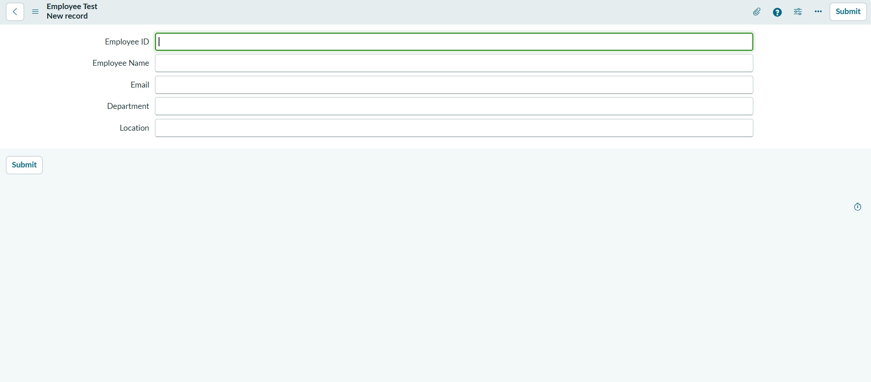
Figure 2: Employee Test form with the five fields
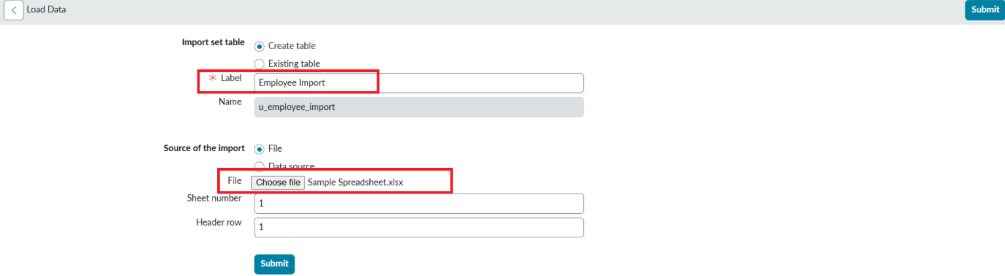
Figure 3: Load Data screen with the Import Set table name and file
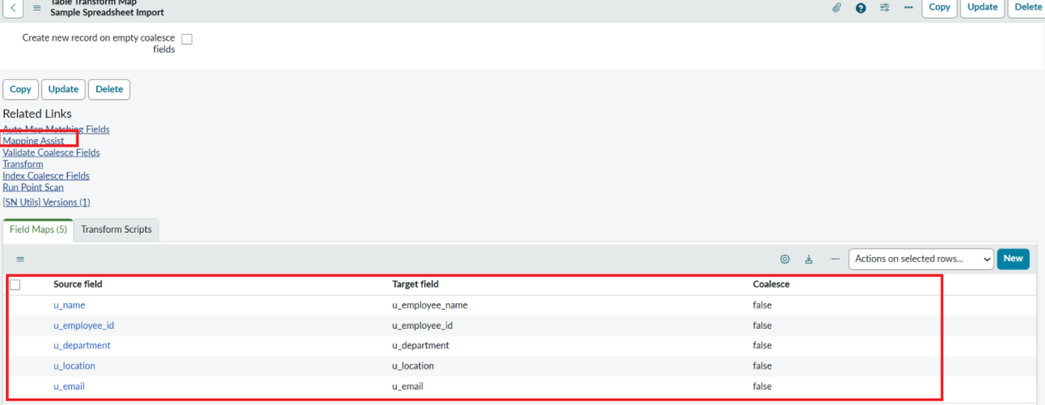
Figure 4: Transform Map field maps
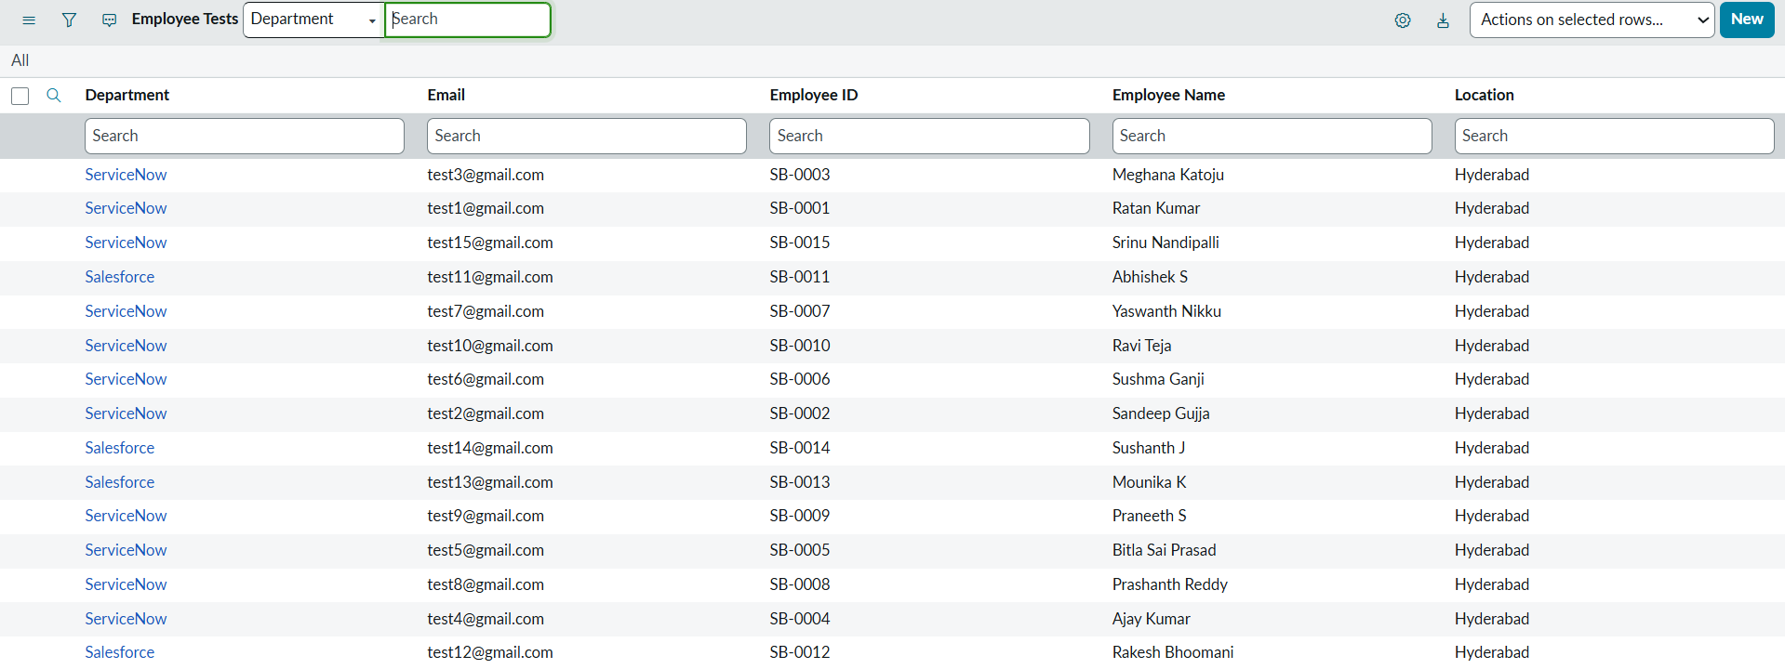
Figure 5: Employee Test list view with the imported records
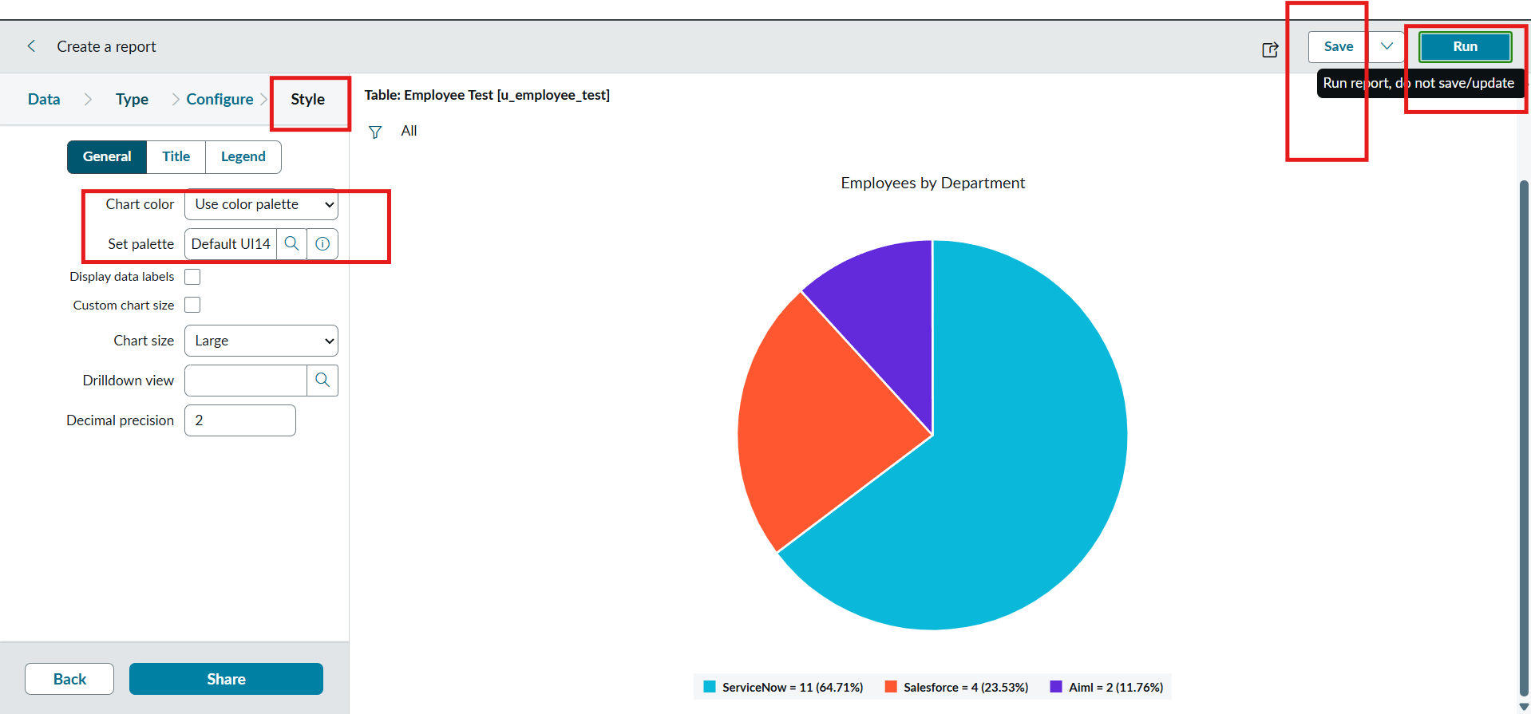
Figure 6: Employees by Department pie chart
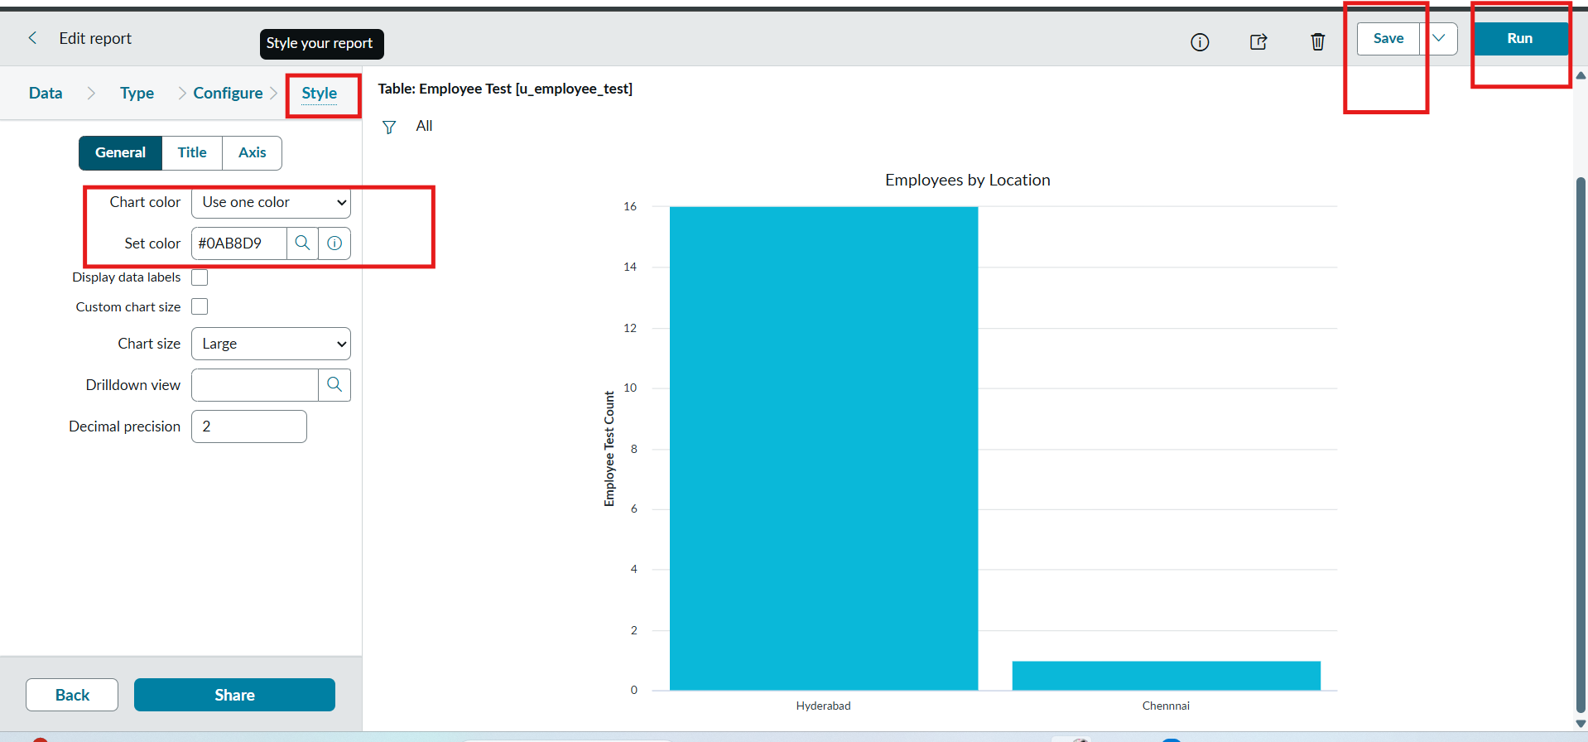
Figure 7: Employees by Location bar chart
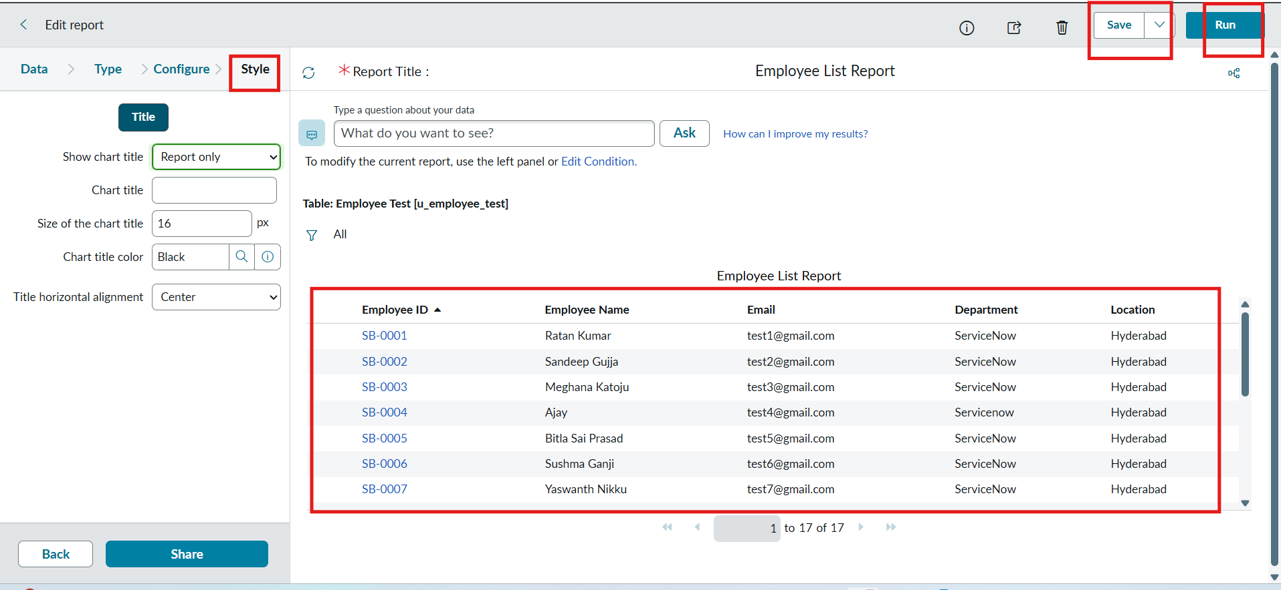
Figure 8: Employee List Report
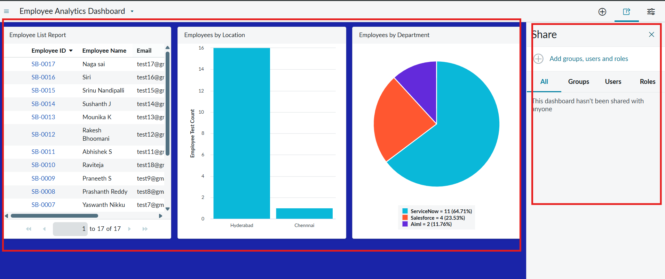
Figure 9: Employee Analytics Dashboard with the three reports

10. Testing
Testing strategy: manual functional testing through User Acceptance Testing (UAT) on the ServiceNow PDI. Eleven test cases (TC-001 to TC-011) cover the table setup, Load Data, Transform Map and field mapping, running the transform, record validation, importing an updated sheet, a negative re-import (duplicate) check, the three reports and the dashboard. No automated test framework was used.
Tools: the ServiceNow Transform History and Import Log, the list view of the Employee Test table, and the Reports and Dashboard views.
Group | Test cases | Total | Result
Setup and import | TC-001 table and fields, TC-002 Load Data | 2 | 2 passed
Transform and mapping | TC-003 Transform Map and field maps, TC-004 run transform | 2 | 2 passed
Validation and duplicates | TC-005 validate records, TC-006 new employee import, TC-007 re-import | 3 | 3 passed
Reports and dashboard | TC-008 pie chart, TC-009 bar chart, TC-010 list report, TC-011 dashboard | 4 | 4 passed
Total |  | 11 | 11 passed, 0 failed, 0 not tested
Import accuracy was 100% on the first load (5 of 5 rows imported with 0 errors), and the re-import with Coalesce enabled created no duplicates (0 inserts, 0 updates, 4 ignored).

11. Screenshots or Demo
Screenshots of the import and the duplicate check are shown below; the user interface screenshots are in section 9.
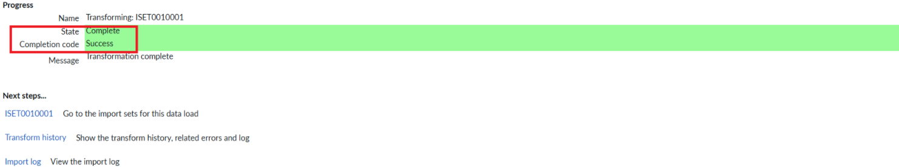
Figure 10: Transform completed with Success
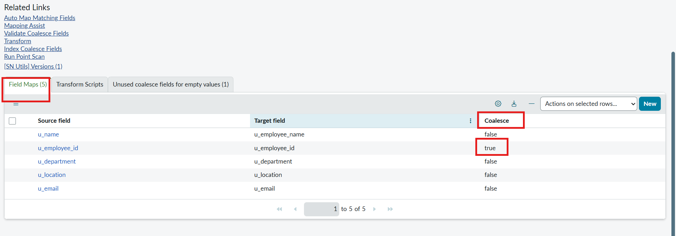
Figure 11: Coalesce set to true on Employee ID
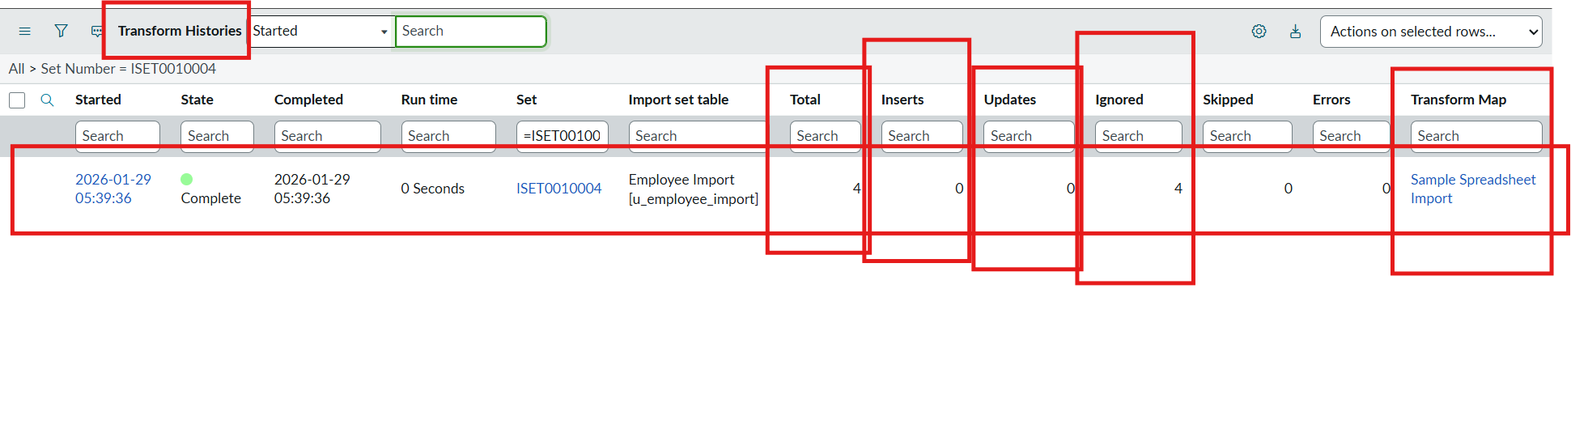
Figure 12: Transform History of the re-import: 0 inserts, 0 updates, 4 ignored
Demo link: [add the project demo video link here]

12. Known Issues
No bugs were recorded in the 11 UAT test cases. The points below are limitations that users and developers should be aware of.
- Importing without Coalesce on Employee ID inserts the same employees again and creates duplicates, so Coalesce must be enabled before re-importing.
- The sheet must have a header row that matches the fields, and the right sheet number and header row must be entered in Load Data; otherwise errors or wrong mappings occur.
- Mapping Assist can map a wrong column if the fields are not checked after mapping.
- Each employee needs a unique Employee ID in the sheet for Coalesce to work.
- The role and ACLs for the Employee Test table (FR-7) are planned but not covered in this release.
- The project was tested on a developer instance with a small sample dataset. An idle PDI goes to sleep and has to be woken before use.

13. Future Enhancements
- Schedule the import so new spreadsheets load automatically instead of by hand.
- Check the sheet for blank cells, typos and duplicate Employee IDs before loading it.
- Add a role and ACLs for the Employee Test table and test access by impersonating users.
- Use transform scripts to clean data (trim spaces, fix text case) and add more fields to the table.
- Reuse the Transform Map approach for other tables and teams.
- Add reports and notifications on import activity (new, updated and ignored rows, failed imports).

